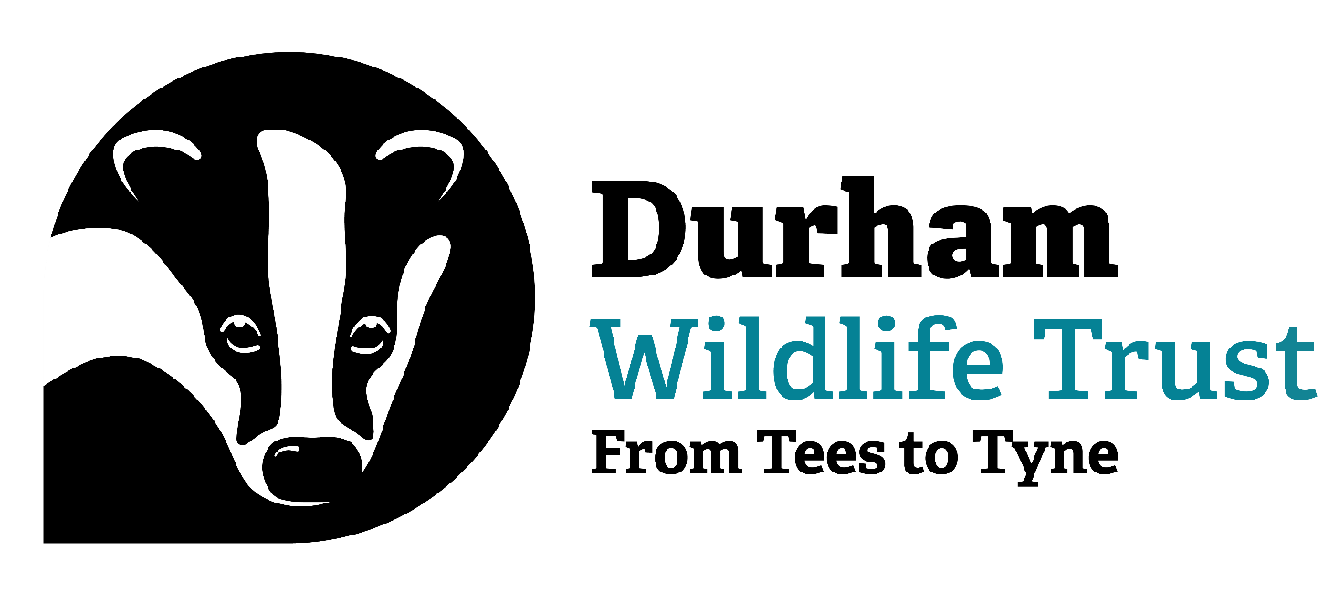

APPLICATION FOR EMPLOYMENT

Durham Wildlife Trust lead for this application process – Emily Routledge

Job Role this application relates to – Development Officer – Grants and Trusts (Maternity Cover)

Durham Wildlife Trust takes its Safeguarding responsibilities extremely seriously. Information on our commitment to safeguarding and safeguarding policies is available on the Trust’s website. The successful applicant for this role will be subject to a Basic Level DBS check that will be repeated every three years. Any offer of employment made in relation to this role will be subject to satisfactory DBS check.

PERSONAL
Forename(s)
Surname
Present Address

Permanent Address
(if different)
Telephone No.
Email
National Insurance Number
Post Applied For
Where did you see the post advertised?

EDUCATION (from secondary level onwards)
Dates | Establishment | Qualifications

TRAINING
Training Courses Attended | Date | Skill/Qualification Obtained

Please give details of any membership(s) of professional bodies

CURRENT OR MOST RECENT EMPLOYMENT
Job title
Name and address of employer:
Date of appointment
Date of leaving
Please outline your duties:
Annual salary
Reason for leaving

PREVIOUS EMPLOYMENT (in date order)
Dates | Employer, including address | Job Title | Reason for leaving

SUPPORT FOR YOUR APPLICATION
Please provide a bullet point summary of the Personal Statement provided in support of your application.

OTHER INTERESTS
Please describe any interests or hobbies that may be relevant to your application

Do you hold a full UK driving licence?
Date licence obtained

REFERENCES
We require details of two referees. One reference should be from your current or most recent employer. If this is not the case please explain why in the space provided below
Reference 1 | Current or most recent employer
Name

Address

Email address
Daytime telephone no
Relationship to you
Can we contact this referee without contacting you first?
Reference 2
Name

Address

Email address
Daytime telephone no.
Relationship to you
Can we contact this referee without contacting you first?

DECLARATION
I accept that in the event of any untrue statement being made on this application form, or a statement being made which Durham Wildlife Trust considers misleading, which by implication covers the omission of any information, Durham Wildlife Trust reserves the right to terminate employment.

Signed: Date:

To apply for this post please complete this application form and also provide a Personal Statement setting out your suitability for the role. The statement must be a maximum of two sides of A4. Form and statement to be submitted to Emily Routledge by email – eroutledge@durhamwt.co.uk

