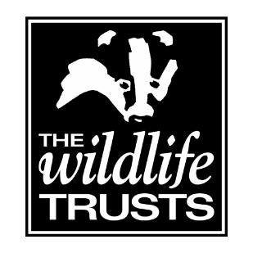

WILDLIFE TRUSTS - APPLICATION FOR EMPLOYMENT

Thank you for choosing to apply for the position of Naturally Native Project Officer. Please return your completed application form along with your CV and covering letter by email to jobs@durhamwt.co.uk no later than 9am Wednesday 4th November 2020.

There are three Project Officer vacancies, one at each of the Trusts. Please indicate below with an X which role or roles you are applying for. You may apply for all three.
Durham WT |  | Northumberland WT |  | Tees Valley WT |  | All three

Forename(s)
Surname
Present Address

Permanent Address
(if different)
Telephone No.
Email
National Insurance Number
Post Applied For
Where did you see the post advertised?

EDUCATION (from secondary level onwards)
Dates | Establishment | Qualifications

TRAINING
Training Courses Attended | Date | Skill/Qualification Obtained

Please give details of any membership(s) of professional bodies

CURRENT OR MOST RECENT EMPLOYMENT
Job title
Name and address of employer:
Date of appointment
Date of leaving
Please outline your duties:
Annual salary
Reason for leaving

PREVIOUS EMPLOYMENT (in date order)
Dates | Employer, including address | Job Title | Reason for leaving

SUPPORT FOR YOUR APPLICATION
Please describe how your past experience makes you suitable for the post.

OTHER INTERESTS
Please describe any interests or hobbies that may be relevant to your application

Do you hold a full UK driving licence?
Date licence obtained

REFERENCES
We require details of two referees. One reference should be from your current or most recent employer. If this is not the case please explain why in the space provided below
Reference 1 | Current or most recent employer
Name

Address

Email address
Daytime telephone no
Relationship to you
Can we contact this referee without contacting you first?
Reference 2 | Personal or previous employer
Name

Address

Email address
Daytime telephone no.
Relationship to you
Can we contact this referee without contacting you first?

DECLARATION
I accept that in the event of any untrue statement being made on this application form, or a statement being made which Durham Wildlife Trust considers misleading, which by implication covers the omission of any information, the Durham Wildlife Trust reserves the right to terminate employment.

Signed: Date:

Please return your completed application form along with your CV and covering letter by email to jobs@durhamwt.co.uk no later than 9am Wednesday 4th November 2020.

