DOCUMENT 1

INVITATION TO TENDER FOR
Stronger Shores – Nearshore Sensor Array Vessel Charter

Contact Details:
Martina Bristow
Seagrass and Seaweed Research Officer
0191 584 3112
mbristow@durhamwt.co.uk

Contents

Introduction 3
Durham Wildlife Trust 5
Invitation to Tender 6
Context and Outline of Work Required 6
Milestones and Deliverables of the Contract 7
ITT and Contract Timescales 8
Payment 8
Appendices and Design Notes 8
Contractor Specification 8
Tenders and deadline for submission 9
Further information 9
Assessment of Tenders 9
Conditions of Tender 10
Canvassing 10
Terms and Conditions 11

Introduction

This specification sets out the works and vessel specification required to deliver supporting services for a nearshore scientific sensor array under the Stronger Shores programme.

Stronger Shores - Nearshore Sensor Array

The Stronger Shores programme is part of a North-East coastal partnership hosted and coordinated by South Tyneside Council. Funded by DEFRA through the Environment Agency managed Flood and Coastal Resilience Innovation Programme, Stronger Shores is assessing the potential for a series of natural habitats to support coastal resilience against storms, flooding and climate change.
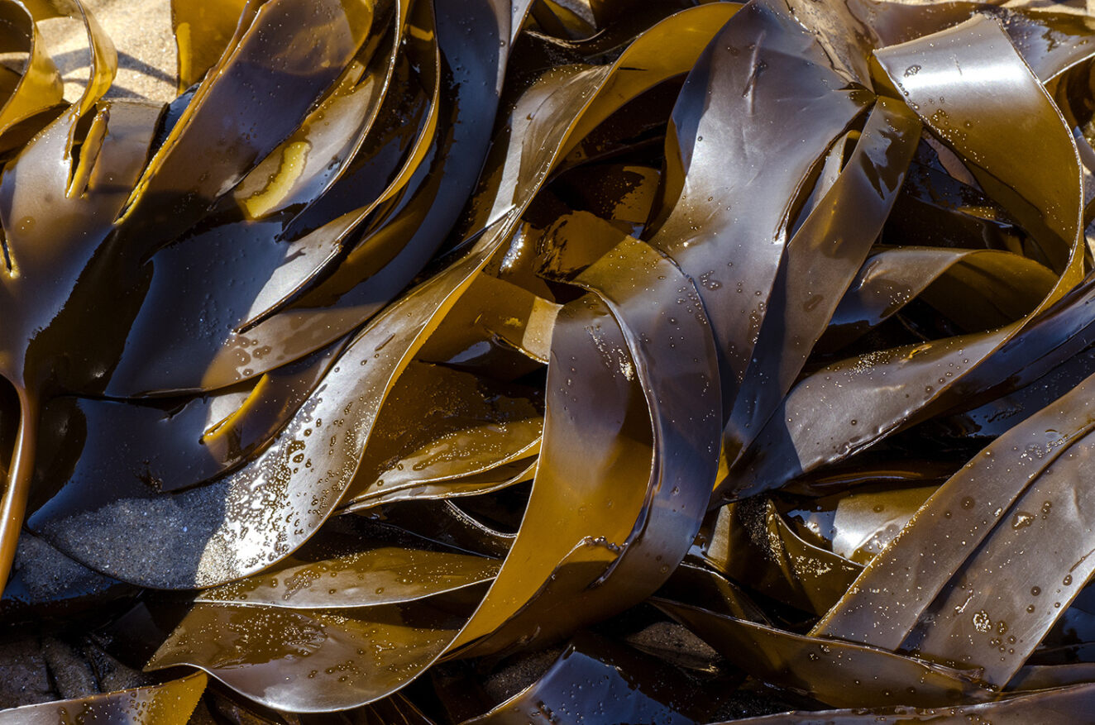

As part of this programme, Durham Wildlife Trust (DWT) and technical partners are assessing and monitoring the environmental influence of kelp seaweed and its contribution to nearshore wave attenuation and biodiversity enhancement.

Durham Wildlife Trust invites tender applications from vessel providers for the regular charter of a nearshore workboat or survey vessel to support the inspection and recovery of scientific instrumentation and KelpedoTM seaweed units by the technical officer and provide transport to allow for associated filming activities.

Location
Whilst the location of the sensor array site is yet to be confirmed, we anticipate that the site will be situated within 2 nautical miles of the Durham coast, and within 5 nautical miles of Seaham harbour. Currently, the preferred site location is east of Hawthorn, situated within a 600m x 100m area given by the following coordinates:
NW: 54.8227° -1.2726°
NE: 54.8227° -1.271°
SW: 54.8173° -1.2726°
SE: 54.8173° -1.271°
Proposed sensor array site at ‘Option 2’ in the above map

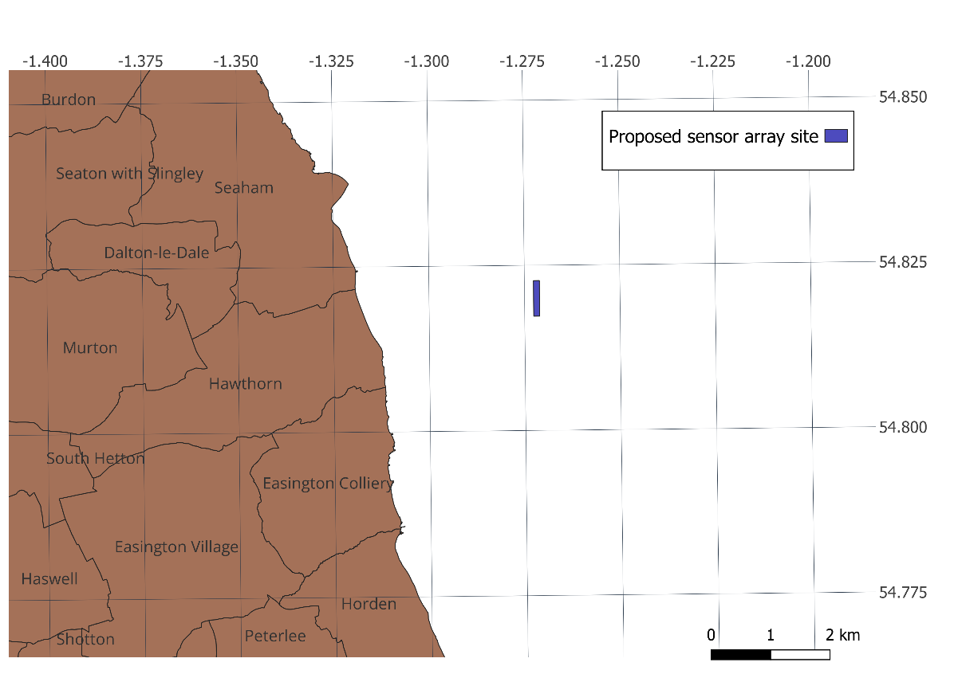
Description
The sensor array will consist of twelve custom-made KelpedoTM seaweed units manufactured and installed by SeaGrown Ltd based in Scarborough. These units will be arranged in a linear fashion in a north-south orientation off the coast of Durham. The twelve units will be deployed at 50m spacings. Therefore, the sensor array site will cover an area of approximately 600m x 100m, although the seabed and surface footprint of each individual unit will be 1m².
The charter will involve the monthly transport of a technical officer to the sensor array site to carry out regular monitoring and maintenance work. The charter vessel crew will assist with inspection of infrastructure and activities of the technical officer. The charter will also conduct occasional transport of an engagement officer and documentary filmmaker to the sensor array site for filming purposes. Transport should be provided to and from Seaham harbour.
The charter will be for a minimum of 1 day per month for the length of the contract, with 4 additional contingency days reserved per year. The charter format is anticipated as 1 day per month starting from May 2024 for a period of 23 months.

Durham Wildlife Trust
Who we are…

Durham Wildlife Trust is a charity and was established in 1971, originally as the Durham County Conservation Trust, becoming Durham Wildlife Trust in 1988. The Trust operates across the area of the old County Durham, which today includes Darlington, Gateshead, South Tyneside and Sunderland.
Durham Wildlife Trust is one of 46 charities across the UK that together form the Wildlife Trusts. Recognised by their badger logo, each individual Wildlife Trust is an independent organisation conserving wildlife in its local area. The Trusts are membership organisations with a strong volunteering tradition. Each Trust was originally founded by dedicated volunteers with a passion to conserve their local wildlife. Acting locally and making a difference nationally.

Durham Wildlife Trust manages 50 nature reserves between the Tees and the Tyne. From ancient woodland and heathland to meadows, wetlands and more, the Trust has protected some of the North East’s most important wildlife sites. Today Durham Wildlife Trust continues to acquire new reserves, helping nature to recover across the landscape and bringing wildlife into the heart of our towns and cities.
Durham Wildlife Trust acts as an advocate for wildlife, inspiring individuals and communities to take action and play their part to address the ecological and climate emergency by restoring nature across our region.
We work as part of a national movement

There are 46 local Wildlife Trusts across the whole of the UK, the Isle of Man and Alderney, all working for an environment rich in wildlife for everyone.

With 850,000 members, we are the largest UK voluntary organisation dedicated to conserving the full range of the UK’s habitats and species, whether they be in the countryside, in cities, or at sea. 135,000 of our members belong to our junior branch, Wildlife Watch.

To find out more…

www.durhamwt.co.uk
www.wildlifetrusts.org

Invitation to Tender

Durham Wildlife Trust (DWT) invites tenders for the works specified in this document.

- DWT is seeking to appoint a vessel provider for the regular charter of a workboat or survey vessel to support the inspection and recovery of scientific equipment and KelpedoTM seaweed units, and associated activities, at a nearshore sensor array.

- Tenderers are advised to read the documents carefully to ensure that they are familiar with the nature and content of their obligations if their tender is accepted.

Tenderers can clarify any points of doubt or difficulty by contacting:
Martina Bristow, Durham Wildlife Trust, Tel: 0191 584 3112
Email: mbristow@durhamwt.co.uk

Context and Outline of Work Required

The successful applicant will provide a charter vessel and crew to support the inspection and recovery of scientific instrumentation and KelpedoTM seaweed units at the Stronger Shores Nearshore Sensor Array, operating out of Seaham harbour.

The vessel charter is required to meet the following specification:

- Vessel specification | - Coding – required to meet MCA Cat 3 workboat coding for 20nm with 6 persons on board during daylight hours.  - Hauling - capacity of over 150 kg line pull.  - Wheelhouse – seating for a minimum of 4 passengers including a dry workstation or table to allow for laptop use and electronic equipment servicing.  - Welfare facilities – a dedicated cubicle with fixed or temporary toilet provision.  - Deck Space - a minimum stern deck space work area of 4m².  - Transit Speed – a cruising operational speed of over 10 knots for transit.  - Gross Weight Limit – an overall vessel weight under 3.5 tonnes, to allow for direct mooring to the KelpedoTM infrastructure.  - Stability – due to the nature of the units and technical equipment, a catamaran is preferred over a mono-hull, particularly for vessels bringing units alongside.  - Length – an overall vessel length of less than 10m
- Regular monthly transport of a technical officer to the sensor array site | One day per month the vessel is required to transport the technical officer to the sensor array site to carry out regular monitoring and maintenance work. This may include the occasional transport of an engagement officer and documentary filmmaker to the site for filming purposes alongside the technical officer.  The charter vessel may be required to stand on station to allow for sensor deployment and recovery over a tidal cycle or return to port between deployment and recovery.
- Flexibility to respond to unexpected events, including providing for an additional four contingency days per year. | Contingency days may be utilised for example,  - Additional inspections following storm events  - The recovery of dislodged surface floats  - Additional surveys within the array or its locality  - Filming or education  Emergency response, for example to inspect infrastructure following storm events or reports of damage to the KelpedoTM units, must be provided within a reasonable timeframe once weather and tide conditions are suitable for travel to the sensor array.
- Assist with inspection of infrastructure and activities of the technical officer | The charter vessel will either recover on board or bring alongside each unit to allow for the recovery of scientific instruments, and assist the technical officer with their recovery, data downloading and battery exchange as well as inspection of surface infrastructure. Inspection of surface infrastructure will include the visual inspection of surface floats and near-surface linkages to the growing units and battery replacement on tracker systems. Charter vessels may be required to stand on station to allow for sensor deployment and recovery over a tidal cycle or return to port between deployment and recovery. Samples of seaweed will also be taken, with some biometrics captured whilst on deck and other samples stored in drums of seawater on board to be returned to shore.
- Arranging moorings and operation out of Seaham harbour | Under normal circumstances, travel to the sensor array site should be from Seaham harbour. It is the responsibility of the charter vessel provider to arrange the necessary moorings and liaise with the harbour authorities.

Milestones and Deliverables of the Contract

Outputs and outcomes

Outputs

12 days regular monthly vessel charter per year with an additional 4 contingency days.

Outcomes

Monitoring, inspecting, and basic repair and upkeep of the scientific sensor array and seaweed cultivation infrastructure.

Monitoring of biodiversity, seaweed growth and biometrics, physical and biogeochemical water properties, including deployment and recovery of sensors and sensor data.

Engagement and Permissions

The successful tenderer will need to provide a plan and outline their approach to facilitating the monitoring activities at sea and obtaining appropriate permissions to operation out of Seaham harbour.

Reporting Arrangements

The successful tenderer will report to Martina Bristow, Durham Wildlife Trust, Rainton Meadows, Chilton Moor, Houghton le Spring, DH4 6PU.

ITT and Contract Timescales

The proposed starting date is May 2024, however this is subject to change depending on licencing. All works to be completed by end of March 2026.

This timetable is indicative only. While Durham Wildlife Trust does not intend to depart from the timetable, it solely reserves the right to do so at any time.

Copyright/Intellectual Property

Title in all work shall pass to Durham Wildlife Trust on payment for that work completed. The risk in any works shall remain with the contractor until delivery is confirmed, accepted and payment made.

Payment

Payment for the charter shall be in arrears following each day’s charter on production of invoices itemising the work carried out and the amount due. Payment will be made within 30 days net of invoice date.

The above are on condition that the DWT contract manager is satisfied with progress.
Bidder’s proposals for this Quotation must be exclusive of all expenses.
All prices submitted must be inclusive of VAT.
The total payable will be no greater than the total amount on the attached Bill of Quantities and included in the ITT Document 2 Tender Response Document.

Appendices and Design Notes

Standard Terms and Conditions for the Provision of Services

Bill of Quantities
For completion and submission with the tender. Please note that all tabs must be completed. See Appendix 2

Scheme Supporting Documents
For supporting documents that inform this tender process please see Appendix 3. This includes Site Redline Boundary.

Contractor Specification
The successful applicant, which may be an individual, company or consortium working to a lead applicant will be expected to demonstrate substantial expertise in delivering similar work. Two referees of similar projects should be provided for the Trust to obtain references.

Tenders and deadline for submission

Those submitting a tender should respond with the following:
- Relevant experience and qualifications, including brief CV(s) of the people leading and working on the charter vessel. This must include details of their experience of delivering similar support for scientific work at sea and monitoring at-sea infrastructure.
- Proposed approach to carrying out the work, including how emergency response might be met, preliminary availability of the vessel, how necessary arrangements with Seaham harbour will be organised, and communication and reporting arrangements with the DWT technical officer. Plan and description of approach should cover points 1-5 in ‘Context and Outline of Work Required’ section above, including all vessel specifications.
- Proposed fee basis.
- Analysis of fee into daily rate and other costs, VAT if applicable.
- Complete ITT Schedule 2 – Tender Response Document including completed Section A pro-formas for all bidding organisations (if bidding as a partnership or consortium).
- Completed and signed Section J – Certificates and Declarations.
- Completed and Signed Section K – Non-Collusive Tendering Certificate.
- Completed Bill of Quantities (Appendix 2).
- Environmental Policy and evidence of how your organisation is progressively working towards reducing its carbon footprint and making a positive impact on the environment.
- Equal Opportunities statement.
- Names and details of two references/referees.

Completed tenders must be returned to:

mbristow@durhamwt.co.uk

Martina Bristow
Durham Wildlife Trust
Rainton Medaows
Chilton Moor
Houghton le Spring
DH4 6PU

The Trust accepts no responsibility for non-receipt of tenders, electronic or otherwise.
The deadline for electronic submissions is 12 noon Wednesday 8th May 2024. We will acknowledge receipt of all tenders as soon as practically possible after we have received them. Please contact Martina Bristow if you require adjustment to the tender submission date.

Further information

Further information can be provided, or an informal telephone discussion arranged, by contacting Martina Bristow, Seagrass and Seaweed Research Officer, Durham Wildlife Trust, 0191 584 3112.

Assessment of Tenders

The tenders will be assessed for value for money, by comparison of the number of days’ activity proposed for the project budget or daily rate, and an assessment of quality based on previous experience of delivering similar work, and approach and methodology proposed for this project.

The balance of assessment will be:

Specification – alignment with the key vessel requirements detailed in the
above section ‘Context and Outline of Work Required’. 40%
Tender quality – response and description on ability to discharge key roles 20%
Value for Money – details on a standard fixed day rate charge, ancillary
charges and any retainer, transit or standby charges 20%
Emergency Responsiveness – details on capacity for rapid response
deployments 10%
Track Record – details and evidence of comparable delivery 10%

Tenders will be assessed using the information provided and we plan to confirm the successful bidder shortly after the submission deadline. The initial project meeting will be held as soon as possible after this date.

Conditions of Tender

Preparation of tender
Tenderers must obtain for themselves, at their own responsibility and expense, all information they deem necessary for the preparation of their tenders.

Great care should be taken in the preparation of this tender because, on receipt, Durham Wildlife Trust will not entertain any request for alteration on the grounds that an error has been made.

Canvassing
Any Tenderer who directly or indirectly canvasses any person acting as a Trustee, committee member or member of staff of Durham Wildlife Trust concerning the award of the contract for the provision of services will be disqualified.

Confidentiality of Tender Information and Documents
All information supplied by Durham Wildlife Trust in connection with this Invitation to Tender shall be regarded as confidential to Durham Wildlife Trust.

Collusive Tendering
Any Tenderer who:
- fixes or adjusts the work to be provided for in their Tender by or in accordance with any agreement or arrangement with any other person; or
- communicates to any person other than Durham Wildlife Trust the details of their proposed Tender (except where such disclosure is made in confidence in order to obtain a quotation necessary for the preparation of the tender for insurance or a contract guarantee bond); or
- enters into any agreement or arrangement with any other person that they shall refrain from tendering or as to the details of any tender to be submitted; or
- offers or agrees to pay or give or does pay or gives any sum of money, inducement or valuable consideration directly or indirectly to any person for doing or having done or causing or having caused to be done in relation to any other tender or proposed tender for the Services any act or omission, is likely (without prejudice to any other civil remedies available and without prejudice to any criminal liability which such conduct by a tenderer may attract) to be disqualified.

Tenders for Selected Services
Tenderers must bid for all of the services specified.

Sub-Contractors
Where a tenderer intends to use sub-contractors, it will be the responsibility of the tenderer to provide the sub-contractor with all necessary information.

The Tender
Tenders must be submitted on the enclosed forms provided within the attached documents.
Tenders must be accompanied by appropriately signed copies of the following:
- the enclosed 'Form of Tender' (ITT 2 Section H);
- the enclosed 'Non-Collusive Tendering Certificate' (ITT 2 Section K); and
- a list of sub-contractors, the items that each will be providing and the relationship with the tenderer if applicable.
- All prices tendered must include VAT if applicable. Durham Wildlife Trust is not VAT registered.
- All documents requiring a signature must be signed:
  - where the Tenderer is an individual, by that individual;
  - where the Tenderer is a partnership by two duly authorised partners; and
  - where the Tenderer is a company, such persons being duly authorised for that purpose.

The Form of Tender and accompanying documents must be fully completed.

Acceptance
Durham Wildlife Trust is not bound to accept the lowest or any Tender.

Tender Information
Tenderers must submit all the information requested in this tender document; this is essential to evaluate the offers received.
Tenderers attention is also drawn to the Non Collusive Tendering Certificate (ITT2 Section K), Environmental Impact (ITT2 Section G) and Equal Opportunities Statement (ITT2 Section E). Appropriate responses must be submitted with your bid.

Terms and Conditions
Unless specifically modified and agreed in writing at the time of contract, the Terms of this Contract will be as detailed in this Invitation to Tender Document, any attached instructions to bidders and within the attached standard Durham Wildlife Trust Terms and Conditions for the Purchase of a Service (Appendix 1).

APPENDIX 1

Durham Wildlife Trust Terms and Conditions for the Purchase of a Service
- Please see separate policy provided
APPENDIX 2
 |  |  | Stronger Shores – nearshore sensor array vessel charter
 | Bill of Quantities
 |  | For | Durham Wildlife Trust |  | By
 |  |  | Chilton Moor
 |  |  | Houghton le Spring
 |  |  | Tyne and Wear
 |  |  | DH4 6PU
 |  | FAO | Martina Bristow |  |  | VAT Reg No.
 |  | Date
 |  |  | Bill of Quantities
 |  |  | Please see specifications as set out in ITT1.
 |  |  | Description | Number | Measure |  | unit cost | Cost (ex VAT) | Cost (incl VAT)
 |  |  | Regular monthly vessel charter | 24 | Days | @ |  | 0.00 | -
 |  |  | Contingency vessel charter (up to 8 days within the contract period/4 days per 12 month period) | 8 | Days | @ |  | 0.00 | -
 |  |  |  | Sub Total |  |  |  | 0.00 | 0.00
 |  |  |  |  | Totals |  |  | £0.00 | £0.00

